

Dr. Amber, Roach inc.
2023-06-29
Dr. Roach
637 Smith Port Suite 687, Joneschester, UT 09910
Phone: 2621400876
Fax: 3777531195

Re: Jacqueline, Gallagher
PHN: 2675998934
Birthdate: 01-Jul-1981
Address: 3753 Brooke Isle Apt. 605, East Karenland, AS 38930
Patient number: 8596843632

To Whom It May Concern:

This is a medical letter to state the above patient is pregnant with expected delivery date of 20-Aug-2025. Hoping this information is satisfactory for your requirements.

Thank you.

Sincerely,
Dr. Amber, Roach
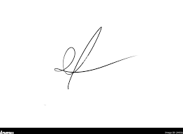
FRCS© NCMP
Clinical Assistant Professor, UBC
Department of Obstetrics and Gynecology SMH

